Dashboard for expediting and logistics

# Home page

The dashboard will give an overview of the critical issues on all projects but through the use of filters will allow you to identify the details on the individual project.

The summary of the tiles below must be represented by sections:

1. First sections (priority to be monitored) the following non-conformities:
   1. DP phase delays
      1. Delayed DOS START
      2. Delayed DOS FINISH
      3. Delayed departure port
      4. Delayed arrival port
   2. MR phase delays
      1. Delayed Contract Date
      2. Delayed Forecast/Actual
      3. Delayed Final/Pre-ship
   3. Total for components between BOM, MR, DP
      1. Qty MR<> Qty DP
      2. Qty DP <> Qty BOM
      3. Qty MR <> Qty BOM
2. Second section:
   1. Qty MR <> Qty DP (per le righe linkate tra MR con DP)
   2. Qty MR <> Qty BOM (per le righe linkate tra MR con BOM)
   3. Qty DP <> Qty BOM (per le righe linkate tra MR con BOM)
   4. Inconsistent DP dates (non-sequential)
      1. EXW > ETD
      2. ETD > ETA
      3. ETA > DOS Baseline START and DOS Act/For START
      4. DOS Baseline START > DOS Baseline FINISH
      5. DOS Act/For START > DOS Act/For FINISH
   5. Incongruent MR(non-sequential) dates
      1. Man.Start Contract Date > Man.FAT Contract Date
      2. Man.Start Forecast/Actual > Man.FAT Forecast/Actual
      3. Man.Start Contract Date > Man.Final/Pre-ship Insp. Cont. Date
      4. Man.Start Forecast/Actual > Man.Final/Pre-ship Insp. Forecast/Actual
      5. Man.FAT Contract Date > Man.Final/Pre-ship Insp. Cont. Date
      6. Man.FAT Forecast/Actual > Man.Final/Pre-ship Insp. Forecast/Actual
   6. Incongruent MRvsDP Dates
      1. EXW <> Man.Final/Pre-ship Insp. Forecast/Actual
3. Third section
   1. Manufacturing status
   2. Delivered status
   3. Date missing in MR
   4. Date missing in DP

All tiles must have a green, yellow, red alert color based on the % of the errors present:

* Green: % of errors <= 10% of total occurrences
* Yellow: % from 11-60
* Red: >60%

**PO Comment:** Based on our discussion, we have internal brainstorming and our proposal is to add an option in main menu and open a separate page all the option:

1. Show tile section
2. Filter and save options
3. Editable devExpress grid

Need to discuss to finalize the approach for the implementation.

Each time you select a tiles, I must have listed a detail with all the occurrences that correspond to the selected criticality.

In this detail, it must be possible to have a hyperlink that sends me back to the associated MR or DP in order to remedy the non-compliance.

# Critical Error

This paragraph will list all errors that are of high priority to monitor

## Delayed DOS Start

In this non-compliance we will count all the lines where there is a delay

Delay means when:

DOS forecast STAR - DOS baseline START >0.

If at least one of the 2 dates is not present it should not be counted as a delay line.

The detail to show will be as follows:

**PO Comment**: We will consider DOS Act/For START fields as DOS forecast STAR

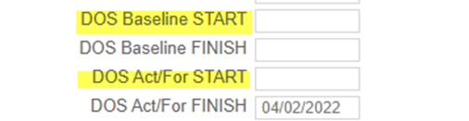

## Delayed DOS Finish

In this non-compliance we will count all the lines where there is a delay

Delay means when:

DOS forecast FINISH - DOS baseline FINISH >0.

If at least one of the 2 dates is not present it should not be counted as a delay line.

The detail to be shown will be as above replacing the date fields

## Delayed departure port

In this non-compliance we will count all the lines where there is a delay

Delay means when:

ATD – ETD >0.

If at least one of the 2 dates is not present it should not be counted as a delay line.

The detail to be shown will be as above replacing the date fields

**PO Comment:**  ATD fields missing on DP form so which field we refer for ATD?

## Delayed arrival port

In this non-compliance we will count all the lines where there is a delay

Delay means when:

ATA – ETA >0.

If at least one of the 2 dates is not present it should not be counted as a delay line.

The detail to be shown will be as above replacing the date fields

**PO Comment**: ATA fields missing on DP form so which field we refer for ATA?

## Delayed Contract Date

In this non-compliance we will count all the lines where there is a delay

Delay means when:

Man. FAT Contract Date - Man. Start Contract Date>0.

If at least one of the 2 dates is not present it should not be counted as a delay line.

The detail to show will be as follows:

**PO Comment**: Ok

## Delayed Forecast/Actual

In this non-compliance we will count all the lines where there is a delay

Delay means when:

Man. FAT Forecast/Actual - Man. Forecast/Actual >0.

If at least one of the 2 dates is not present it should not be counted as a delay line.

The detail to show will be as above.

**PO Comment**: As per our understanding, We will consider Man.Start Forecast/Actual fields as Man. Forecast/Actual. Please confirm.

## Delayed Final/Pre Ship.

In this non-compliance we will count all the lines where there is a delay

Delay means when:

Man. Final/Pre ship. Inst Forecast/Actual - Man. Final/Pre ship. Insp. Contract Date >0.

If at least one of the 2 dates is not present it should not be counted as a delay line.

The detail to show will be as above.

PO Comment: As per our understanding, We will consider Man.Final/Pre-ship Insp. Forecast/Actual as Man. Final/Pre ship. Inst Forecast/Actual. Please confirm.

## Qty MR <> Qty DP

The purpose of this tiles is to verify the differences in aggregate quantities for each component present in the MR and DP. In this case I could also notice the differences due to the fact that a component is present in the MR and not in the DP and vice versa

If I have multiple rows (for example) of Blade, DC Panel and Tower-T1 in the dashboard I report only one per component aggregating the quantities

**PO Comments**: OK

## Qty MR <> Qty BOM

The purpose of this tiles is to verify the differences in aggregate quantities for each component present in the MR and BOM. In this case I could also notice the differences due to the fact that a component is present in the MR and not in the BOM and vice versa (perhaps due to a cancellation by mistake)

If I have multiple rows (for example) of Blade, DC Panel and Tower-T1 in the dashboard I report only one per component aggregating the quantities

Comments-The columns BOM is showing DP qty and The DP column is showing BOM qty

**PO Comments**: OK

## Qty DP <> Qty BOM

The purpose of this tiles is to verify the differences in aggregate quantities for each component present in the DP and BOM. Since there is no Qty of the DP in the BOM I will have to use the Contractual Qty as a yardstick.

In this case I could also notice the differences due to the fact that a component is present in the DP and not in the BOM and vice versa (perhaps due to a cancellation by mistake)

If I have multiple rows (for example) of Blade, DC Panel and Tower-T1 in the dashboard I report only one per component aggregating the quantities

**PO Comments**: OK

Abhishek Comments-The quantity must consider also the splits or the batches

# Medium Error

This paragraph will list all errors that are of average priority to be monitored

## Qty MR <> Qty DP (mismatch)

Unlike the non-compliance indicated in the previous chapter, here the exception must be managed if there is an MR associated with a DP in which the quantity is valued differently.

As a result, only the rows for which there is a match between MR and DP will be shown and the quantity is different.

The detail will be as follows:

**PO Comments**: OK

## Qty MR <> Qty BOM (mismatch)

Unlike the non-compliance indicated in the previous chapter, here the exception must be managed if there is an MR associated with a BOM in which the Qty present in the MR is different from the contractual Qty present in the BOM.

Only the rows for which there is a match between MR and BOM and the quantity is different will then be shown.

The detail will be as follows:

**PO Comments**: OK

## EXW > ETD

With this non-compliance you want to monitor the correct sequence of dates.

In this specific case I have to verify that EXW > ETD. In case it is not so, I report the anomaly

Both dates must be valued otherwise I do not have to report the line as an anomaly count.

**PO Comments**: OK

## ETD > ETA

With this non-compliance you want to monitor the correct sequence of dates.

In this specific case I have to verify that the ETD> ETA. In case it is not so, I report the anomaly

Both dates must be valued otherwise I do not have to report the line as an anomaly count.

**PO Comments**: OK

## ETA > DOS Baseline START and DOS Act/For START

With this non-compliance you want to monitor the correct sequence of dates.

In this specific case I have to check that the ETA > DOS Baseline START and DOS Act/For START (i.e. ETA greater than both dates). In case it is not so, I report the anomaly

All dates must be valued otherwise I do not have to report the line as an anomaly count.

**PO Comments**: OK

## DOS Baseline START > DOS Baseline FINISH

With this non-compliance you want to monitor the correct sequence of dates.

In this specific case I have to check that the DOS Baseline START > DOS Baseline FINISH. In case it is not so, I report the anomaly

All dates must be valued otherwise I do not have to report the line as an anomaly count

**PO Comments**: OK

## DOS Act/For START > DOS Act/For FINISH

With this non-compliance you want to monitor the correct sequence of dates.

In this specific case I have to verify that the DOS Act/For START > DOS Act/For FINISH. In case it is not so, I report the anomaly

All dates must be valued otherwise I do not have to report the line as an anomaly count

**PO Comments**: OK

## Man.Start Contract Date > Man.FAT Contract Date

With this non-compliance you want to monitor the correct sequence of dates.

In this specific case I have to verify that the Man Start Contract Date > Man.FAT Contract Date. In case it is not so, I report the anomaly

All dates must be valued otherwise I do not have to report the line as an anomaly count

**PO Comments**: OK

## Man.Start Forecast/Actual > Man.FAT Forecast/Actual

With this non-compliance you want to monitor the correct sequence of dates.

In this specific case I have to check that the Man.Start Forecast/Actual > Man.FAT Forecast/Actual. In case it is not so, I report the anomaly

All dates must be valued otherwise I do not have to report the line as an anomaly count

**PO Comments**: OK

## Man.Start Contract Date > Man.Final/Pre-ship Insp. Cont. Date

With this non-compliance you want to monitor the correct sequence of dates.

In this specific case I have to verify that the Man.Start Contract Date > Man.Final/Pre-ship Insp. Cont.  **Dates**. In case it is not so, I report the anomaly

All dates must be valued otherwise I do not have to report the line as an anomaly count

**PO Comments**: OK

## Man.Start Forecast/Actual > Man.Final/Pre-ship Insp. Forecast/Actual

With this non-compliance you want to monitor the correct sequence of dates.

In this specific case I have to verify that the Man Start Forecast/Actual > Man.Final/Pre-ship Insp. Forecast/Actual. In case it is not so, I report the anomaly

All dates must be valued otherwise I do not have to report the line as an anomaly count

**PO Comments**: OK

## Man.FAT Contract Date > Man.Final/Pre-ship Insp. Cont. Date

With this non-compliance you want to monitor the correct sequence of dates.

In the specific case I have to verify that the Man FAT Contract Date > Man.Final/Pre-ship Insp. Cont. Dates. In case it is not so, I report the anomaly

All dates must be valued otherwise I do not have to report the line as an anomaly count

**PO Comments**: OK

## Man.FAT Forecast/Actual > Man.Final/Pre-ship Insp. Forecast/Actual

With this non-compliance you want to monitor the correct sequence of dates.

In this specific case I have to verify that the Man FAT Forecast/Actual > Man.Final/Pre-ship Insp. Forecast/Actual. In case it is not so, I report the anomaly

All dates must be valued otherwise I do not have to report the line as an anomaly count

**PO Comments**: OK

## EXW <> Man.Final/Pre-ship Insp. Forecast/Actual

With this non-compliance you want to monitor the correct sequence of dates.

In this specific case I have to verify that the EXW <> Man.Final/Pre-ship Insp. Forecast/Actual. In case it is not so, I report the anomaly

To show non-compliance there must be the association between MR and DP

All dates must be valued otherwise I do not have to report the line as an anomaly count

**PO Comments**: OK

Abhishek Comments- change Tile to EXW = Man.Final/Pre-ship Insp. Forecast/Actual.

# Low Error

This paragraph will list all errors that are of low priority to be monitored

## Manufacturing status

This tiles must count all occurrences that have

Man.Final/Pre-ship Insp. Forecast/Actual < Today and flag “Working Status” not set.

**PO Comments**: Need discussion for more details of the requirement

Abhishek Comments-Can we make the flag available for editing in the dashboard area?

## Delivered status

This tile must count all occurrences that have

DOS Act/For FINISH < Today and flag “Delivered” non set

**PO Comments**: Need discussion for more details of the requirement

Abhishek Comments-Can we make the flag available for editing in the dashboard area?

## Date missing in MR

The purpose of this tiles is to count the number of all empty dates within the MR.

The detailed table must include all the dates in the MR; I will not show a line of MR if and only if all the dates present are populated. Otherwise (even just one missing) I will show the line.

We require a table showing all the MR where a date is missing.

See the example below, Man. FAT forecast/actual is missing then the MR must be counted in the tails.

The table must have always all the columns displayed, showing also the compiled dates

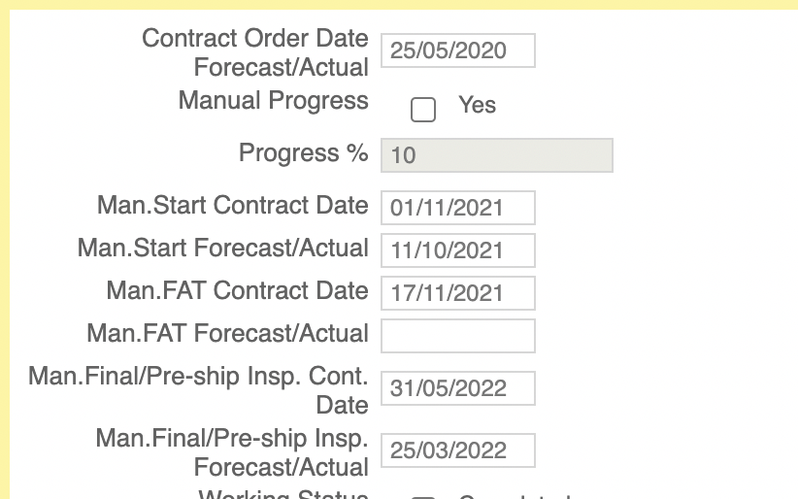

**PO Comments**: Need discussion for more details of the requirement

## Date missing in DP

The purpose of this tiles is to count the number of all empty dates within the DP

The detailed table must include all the dates in the DP; I will not show a line of DP if and only if all the dates are populated. Otherwise (even just one missing) I will show the line.

Same approach as described in the previous paragraph

**PO Comments**: Need discussion for more details of the requirement

Abhishek Comments-The blocked cells date in DP must not be visible, but only in case there are other missing dates.

This must consider when the dp Sorce field=Local:  
1. If=Local then the objects must be counted only if any of other dates than **ETA, ETD, Custom Clearance** is missing  
1.1 for the records founds from the above, **only the fields ETA, ETD, Custom Clearance is missing must be disabled for editing** - other dates fields remain editable

## QTY Container Missing

Comments- The column is wrong, we are taking the container type (WRONG) must be taken the QTY container field

**Sourcing=Local and QTY Containers=Null MUST BE excluded** from the count and in grid